Student Name: Weight: 25%
Student ID: Marks: /40

Assignment: Using JavaScript and Deploying a Website
In this assignment, you’ll demonstrate your ability to use CSS and JavaScript, and to use GitHub for deployment. This assignment may be completed during a provided work period or outside of scheduled class time, as indicated by your instructor.

Instructions
- Working individually, update the website provided by your instructor to add styling and interactive functionality using JavaScript.
- Deploy your website using GitHub.
- Upload the following to Brightspace:
- The URL for your website in the format https://USERNAME.github.io/REPO-NAME, where USERNAME has been replaced with your GitHub ID and REPO-NAME has been replaced with the name of the repository containing the following files and folders for your website:
- Your index.html file
- A pages folder containing booking.html and contact.html
- A styles folder containing styles.css
- An images folder containing the images for your page
- A scripts folder containing one or more JS files, named semantically
- A screenshot showing successful validation of your CSS from http://jigsaw.w3.org/css-validator/
- A screenshot showing successful validation of your JavaScript file from https://beautifytools.com/javascript-validator.php
- Submit your assignment by the due date listed in Brightspace. See the marking criteria below for details on how you will be assessed.

Main page (showing hover-state):



Booking page:

Before clicking
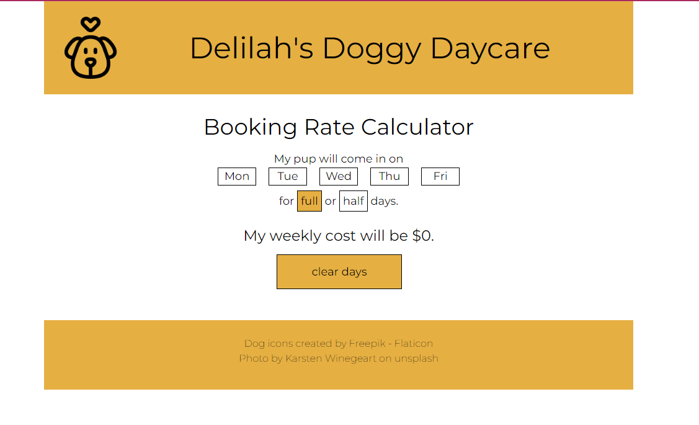

After selecting 2 half-days, showing hover state:

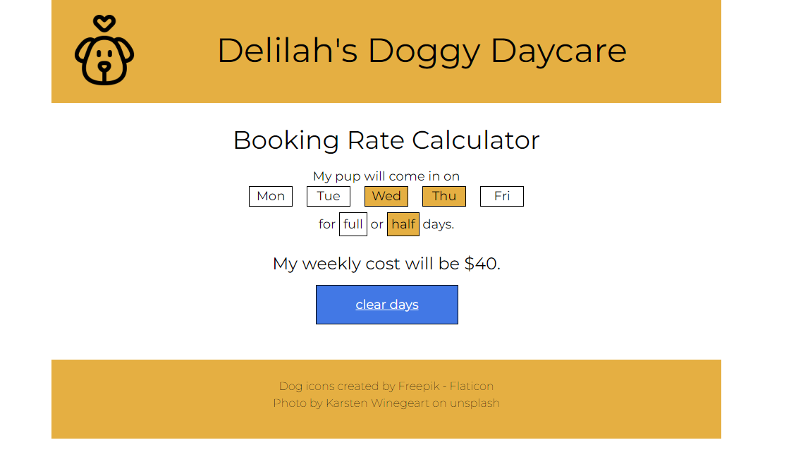

Contact page:

Before input
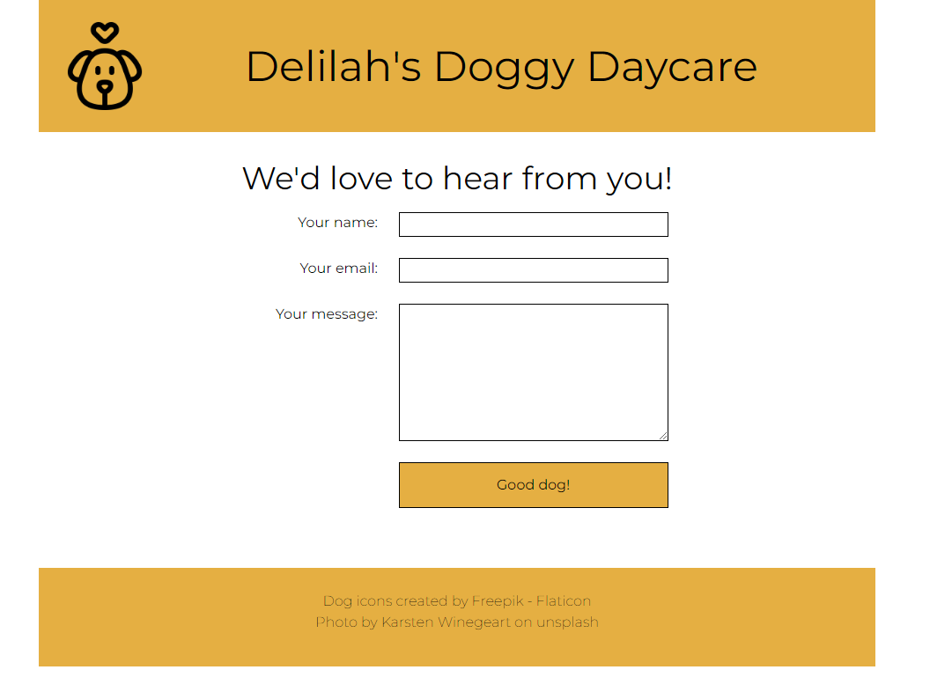

After input
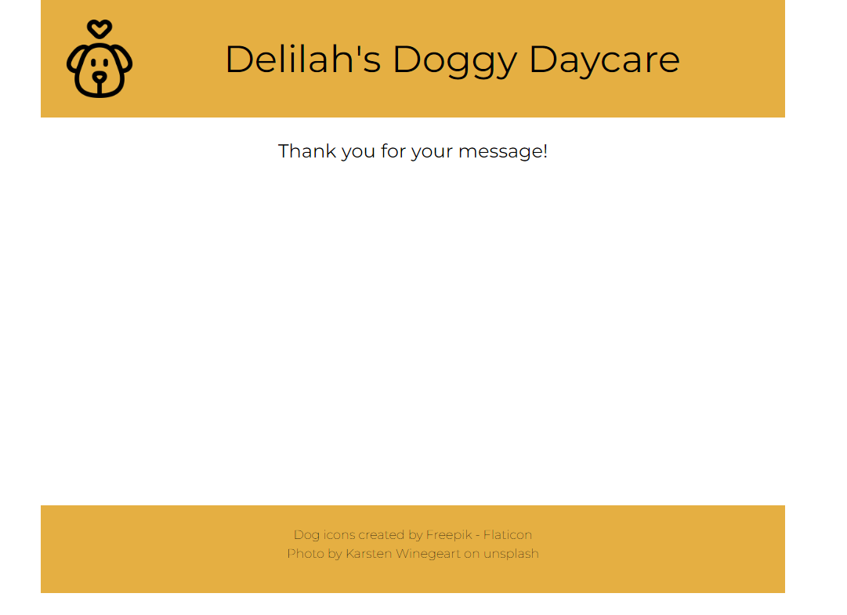

Marking Criteria
 | 0 Marks | 1 Mark | 2 Marks | Marks
HTML | No HTML is submitted. | Code is visible on the page. | Page renders without visible errors. | /2
HTML | No HTML is submitted. | HTML has been modified. | HTML has not been modified, with the exception of adding classes or IDs to existing elements. | /2
CSS | No CSS is submitted. | CSS stylesheet is not correctly linked, or multiple stylesheets were created. | A single CSS file is correctly linked to all 3 web pages. | /2
CSS | No CSS is submitted. | CSS has one or more errors in validation. | CSS passes validation with no errors. | /2
CSS | No CSS is submitted. | CSS contains inconsistent indentation, unnecessary blank lines, incorrect selectors, or significant repetition within declarations, or does not contain comments to organize content. | CSS is well formatted, with minimal repetition and uses comments to organize content. Appropriate and simple selectors have been used. | /2
JavaScript | JavaScript was not included. | JavaScript is embedded within HTML. | JavaScript is contained in its own file(s), linked to the HTML files. | /2
JavaScript | Variables were not included. | Variables were used incorrectly. | Variables use appropriate data types. | /2
JavaScript | Booking day select/clear logic is missing or non-functional. | Booking day select/clear logic is partially correct. | Booking day select/clear logic works as expected. | /2
JavaScript | Booking rate select logic is missing or non-functional. | Booking rate select logic is partially correct. | Booking rate select logic works as expected. | /2
JavaScript | Contact form submit logic is missing or non-functional. | Contact form submit logic is partially correct. | Contact form submit logic works as expected. | /2
JavaScript | JavaScript was not included. | JavaScript has warnings. | JavaScript has no errors or warnings. | /2
GitHub | Link not provided. | Link does not work, or is not in the expected format. | Link works in provided format. | /10
Pages | Home page is missing or blank. | Home page differs significantly from provided sample. | Home page is a reasonable replica of the provided content. | /2
Pages | Bookings page is missing or blank. | Bookings page differs significantly from provided sample. | Bookings page is a reasonable replica of the provided content. | /2
Pages | Contact page is missing or blank. | Contact page differs significantly from provided sample. | Contact page is a reasonable replica of the provided content. | /2
Framework | No files or folders were included. | Framework was missing elements, or did not follow expected structure. | Folder structure was as expected. | /2
Total |  |  |  | /40

